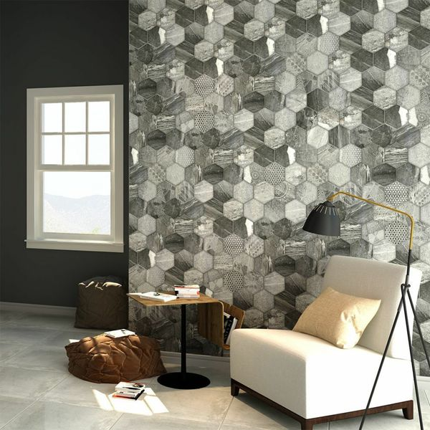**Ruvido Tribal Stone Hexagon Tiles:**

## **Product Description**

A medley of interesting tribal-esque designs printed on a soft stone effect backing, these Tribal Stone Tiles are perfect for introducing a unique floor area into your home. They depict the illusion of 8 individual hexagonal pieces - divided with a faux groutline. Made from durable porcelain, they are perfect for use on all floor area throughout the home. They have a soft matt finish.

The colour of grout used is down to your own personal taste, but one recommendation might be to use our [Mapei Ultracolour Plus 113 Tile Grout](https://www.wallsandfloors.co.uk/catrangetiles/tile-grouts/mapei-grouts/mapei-ultracolour-plus-113-grout/16723/).

## **Product Info**

* Product ID 14325
* Tiles Per SQM 6.36
* Sale by Per SQM
* Size 450x450x9mm
* Weight 3.23 KG
* Material Type Porcelain
* Finish Matt
* Colour Grey
* Suitability Floors, Walls
* Grade 4
* Rectified Edge No
* Underfloor Heating Yes
* Thickness (mm) 7